Electronic Bulletin, video announcement, enewsletter February 2021
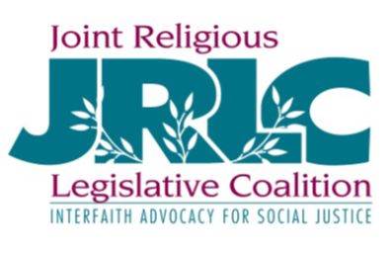
How do you care for those who experience poverty and homelessness? Support pathways out of homelessness? How does your faith move you to act with compassion and for justice? The Joint Religious Legislative Coalition (JRLC) supports your engagement as faithful citizens. JRLC offers learning and opportunities for statewide social justice advocacy. Please join us for the annual JRLC Virtual Day on the Hill – Make Justice Your Aim Isaiah 1:17. The program is Thursday, March 11 from 6:30 – 8:45 p.m. and will examine justice for Minnesotans of color and those who are unsheltered in the context of COVID-19 vaccines. Then we'll prepare to meet legislators to work for justice. Registration details and legislative visit information at 2021 Day on the Hill.
Questions contact Joan Miltenberger, Statewide Organizer, jmiltenberger@jrlc.org, 612-230-3232.

